Create Github Repository And Clone It

Sign Up
# Source: ScreenShots Source: Provided by: [Persons Table -> ID Column: 1, Name_En Column: Motasem Essam] -> Tool: [Lightshot Program] -> From [Site: Google Search: All: Git] on [2/16/2026]
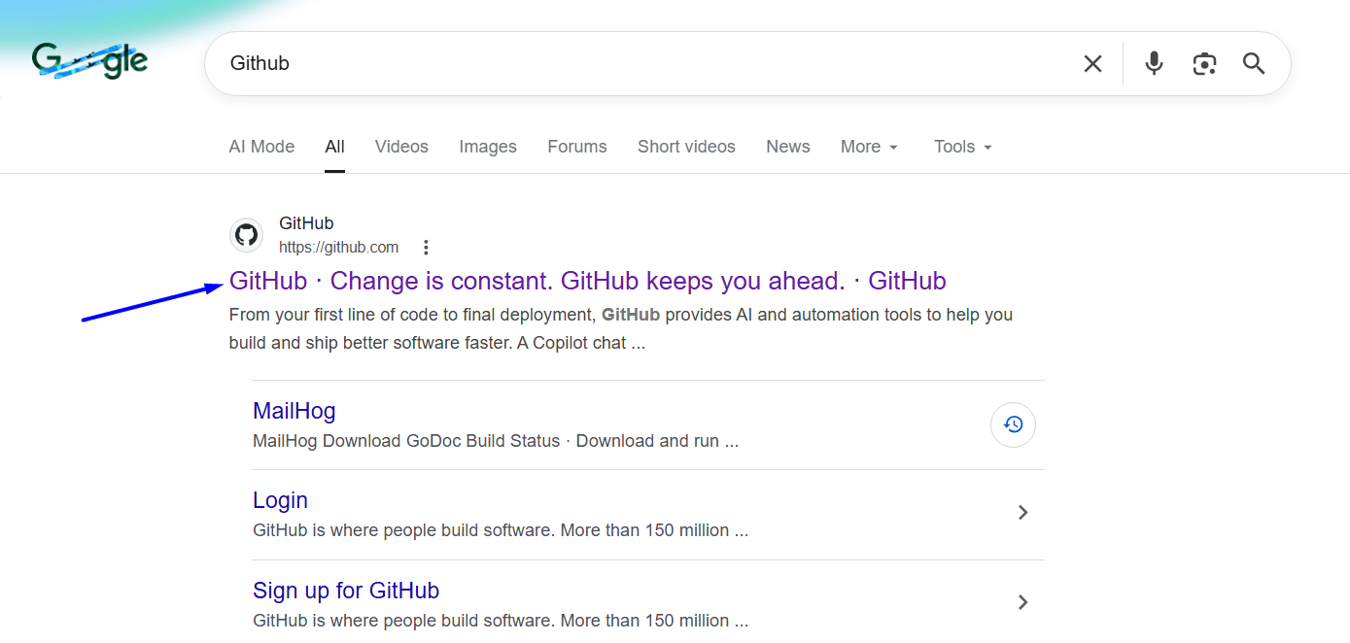
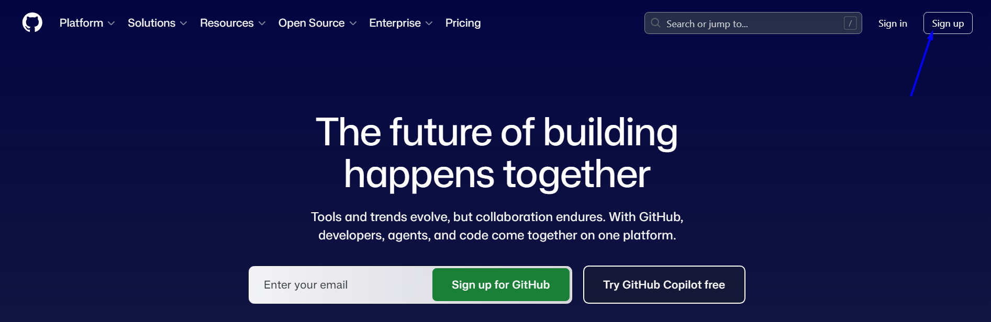
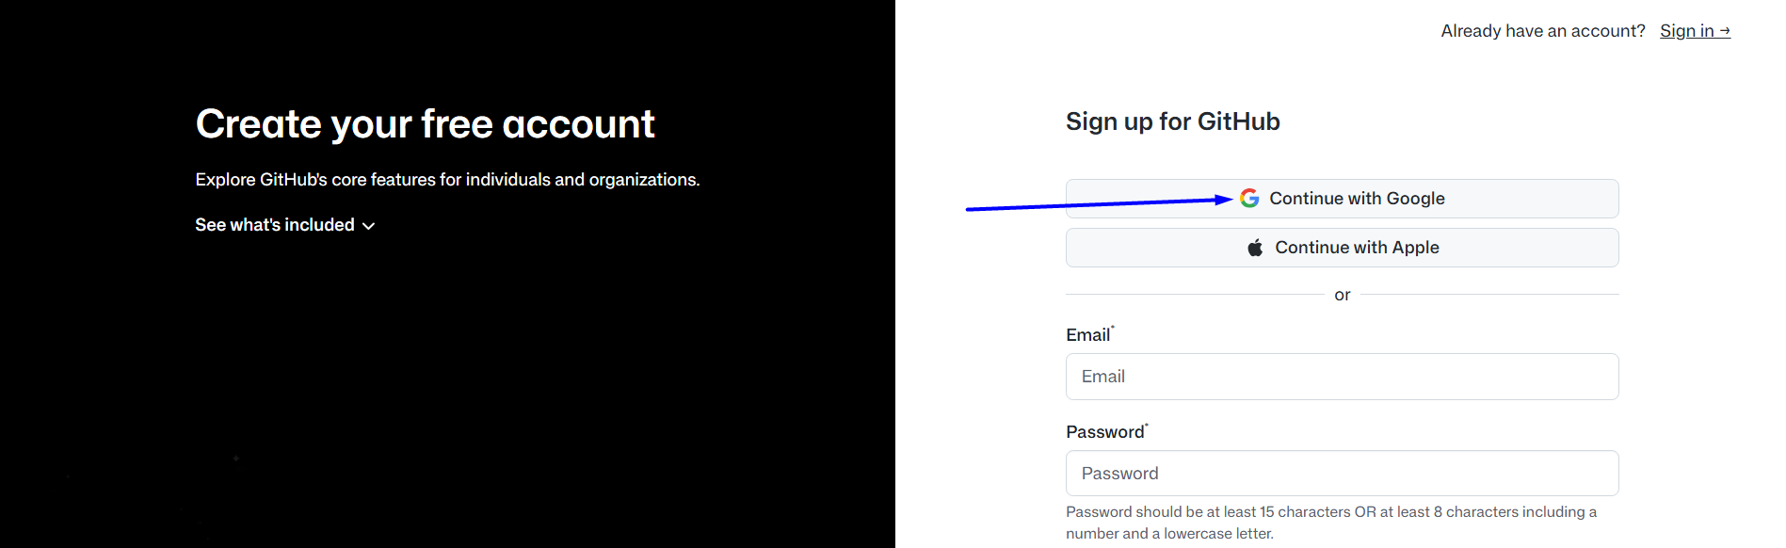
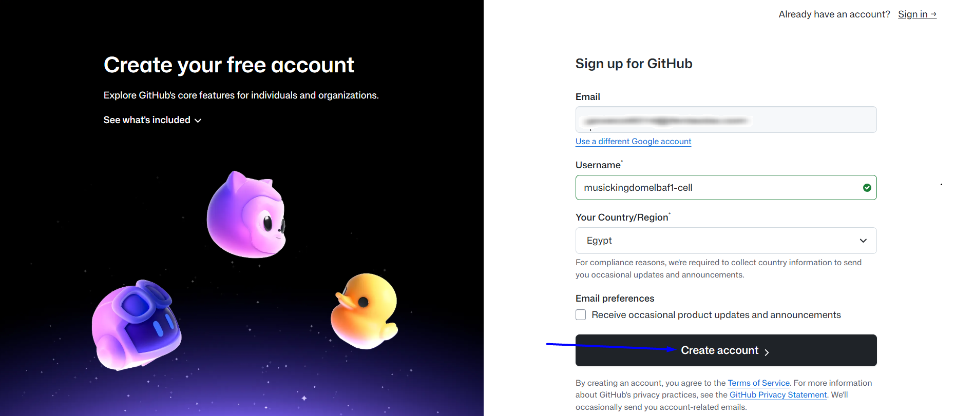
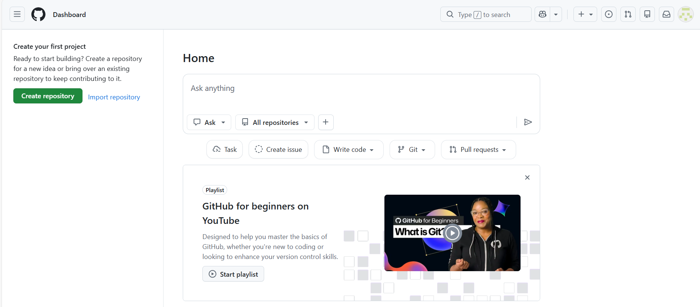

Create repository
# Source: ScreenShots Source: Provided by: [Persons Table -> ID Column: 1, Name_En Column: Motasem Essam] -> Tool: [Lightshot Program] -> From [Site: https://github.com/] on [2/16/2026]
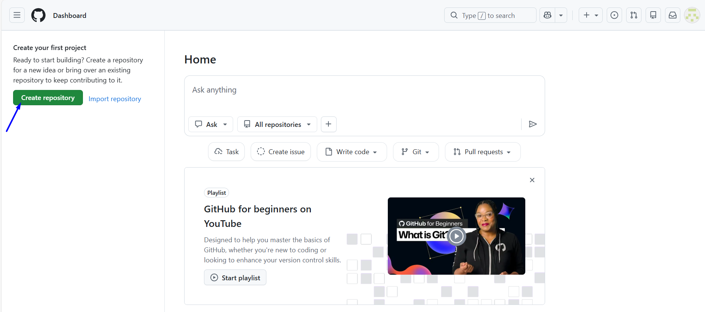
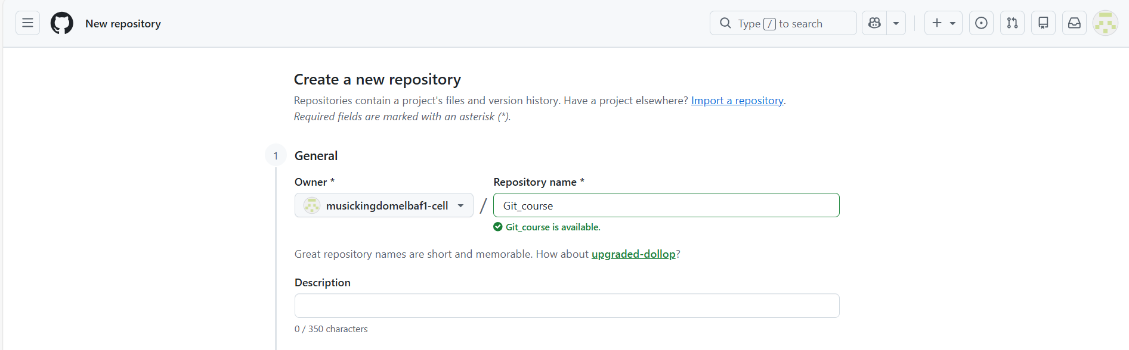

Create repository Without Readme
# Source: ScreenShots Source: Provided by: [Persons Table -> ID Column: 1, Name_En Column: Motasem Essam] -> Tool: [Lightshot Program] -> From [Site: https://github.com/] on [2/16/2026]
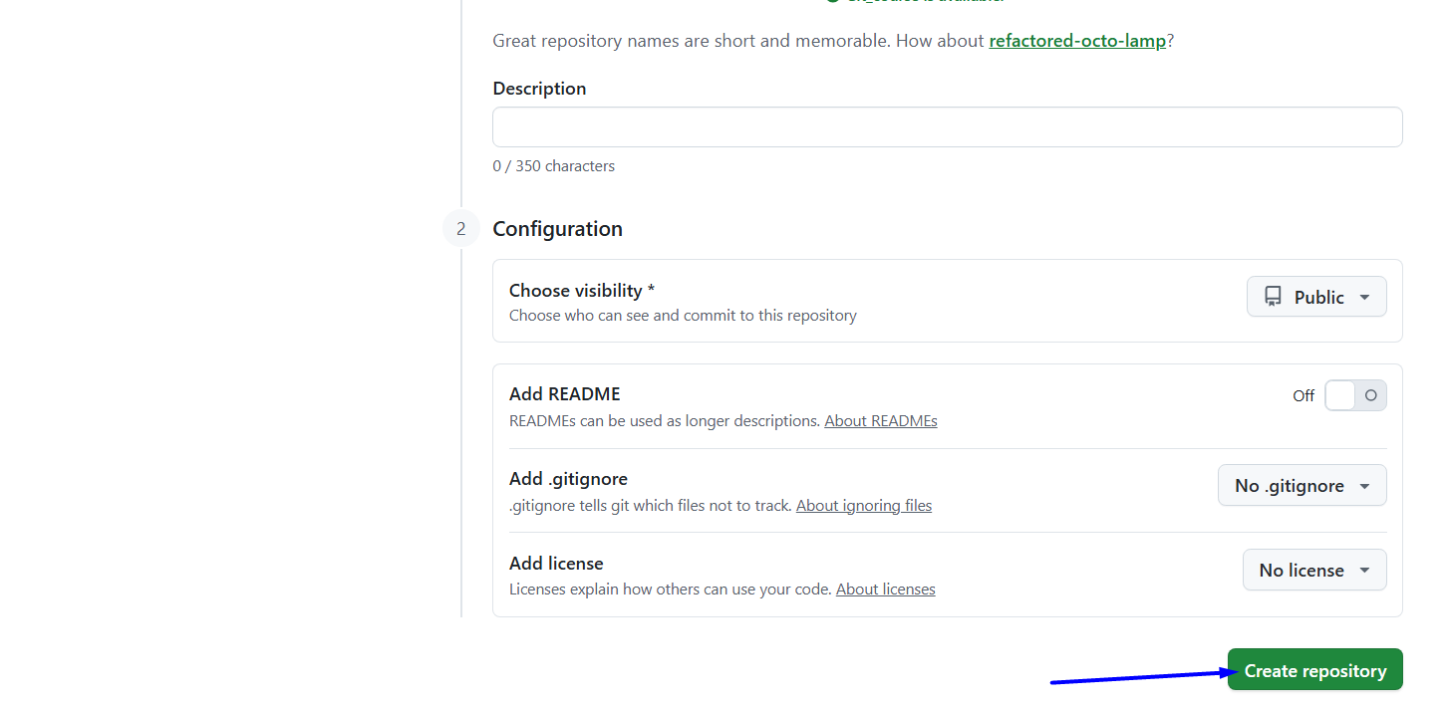
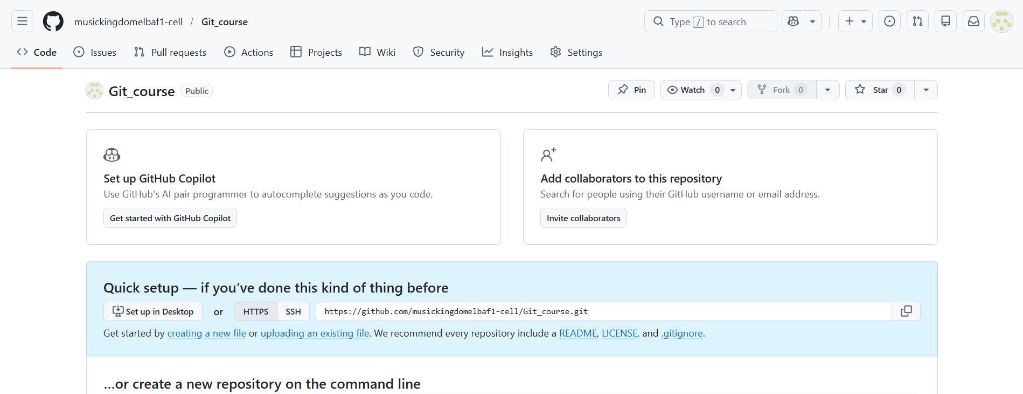
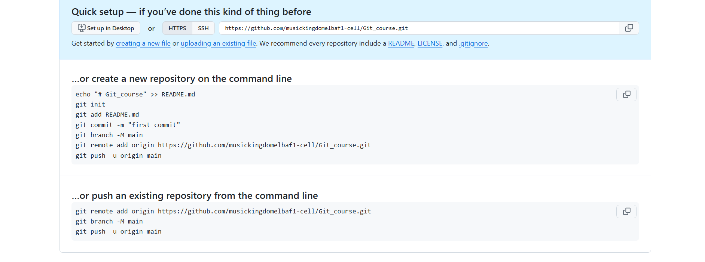

…or create a new repository on the command line
echo "# Git_course" >> README.md
git init
git add README.md
git commit -m "first commit"
git branch -M main
git remote add origin https://github.com/musickingdomelbaf1-cell/Git_course.git
git push -u origin main

…or push an existing repository from the command line
git remote add origin https://github.com/musickingdomelbaf1-cell/Git_course.git
git branch -M main
git push -u origin main

Create repository with Readme
# Source: ScreenShots Source: Provided by: [Persons Table -> ID Column: 1, Name_En Column: Motasem Essam] -> Tool: [Lightshot Program] -> From [Site: https://github.com/] on [2/16/2026]

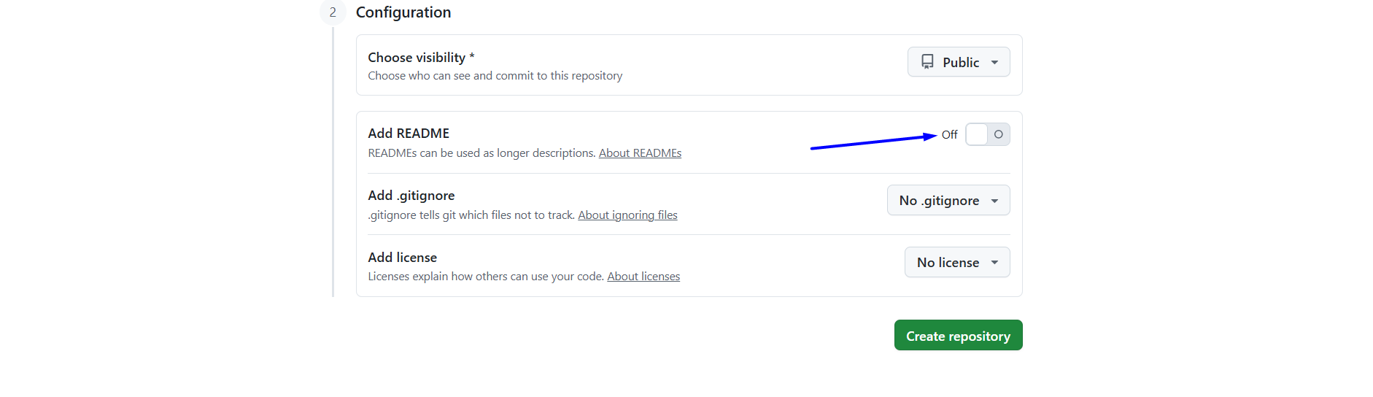
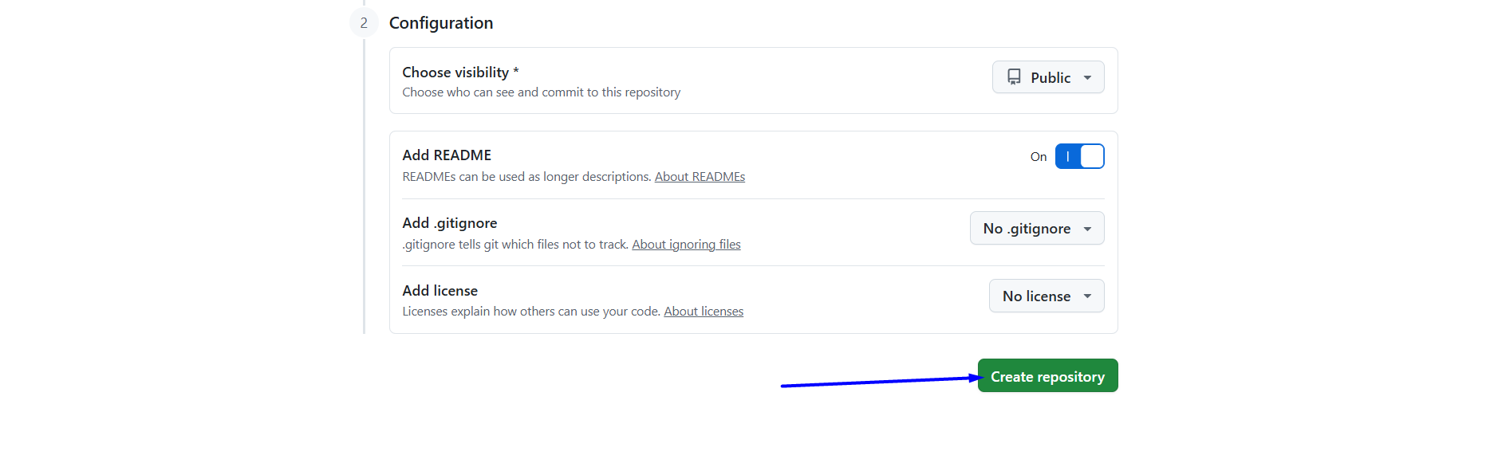
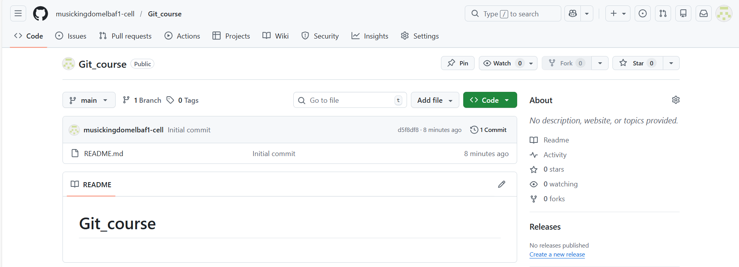

Edit Readme
# Source: ScreenShots Source: Provided by: [Persons Table -> ID Column: 1, Name_En Column: Motasem Essam] -> Tool: [Lightshot Program] -> From [Site: https://github.com/musickingdomelbaf1-cell/Git_course] on [2/16/2026]
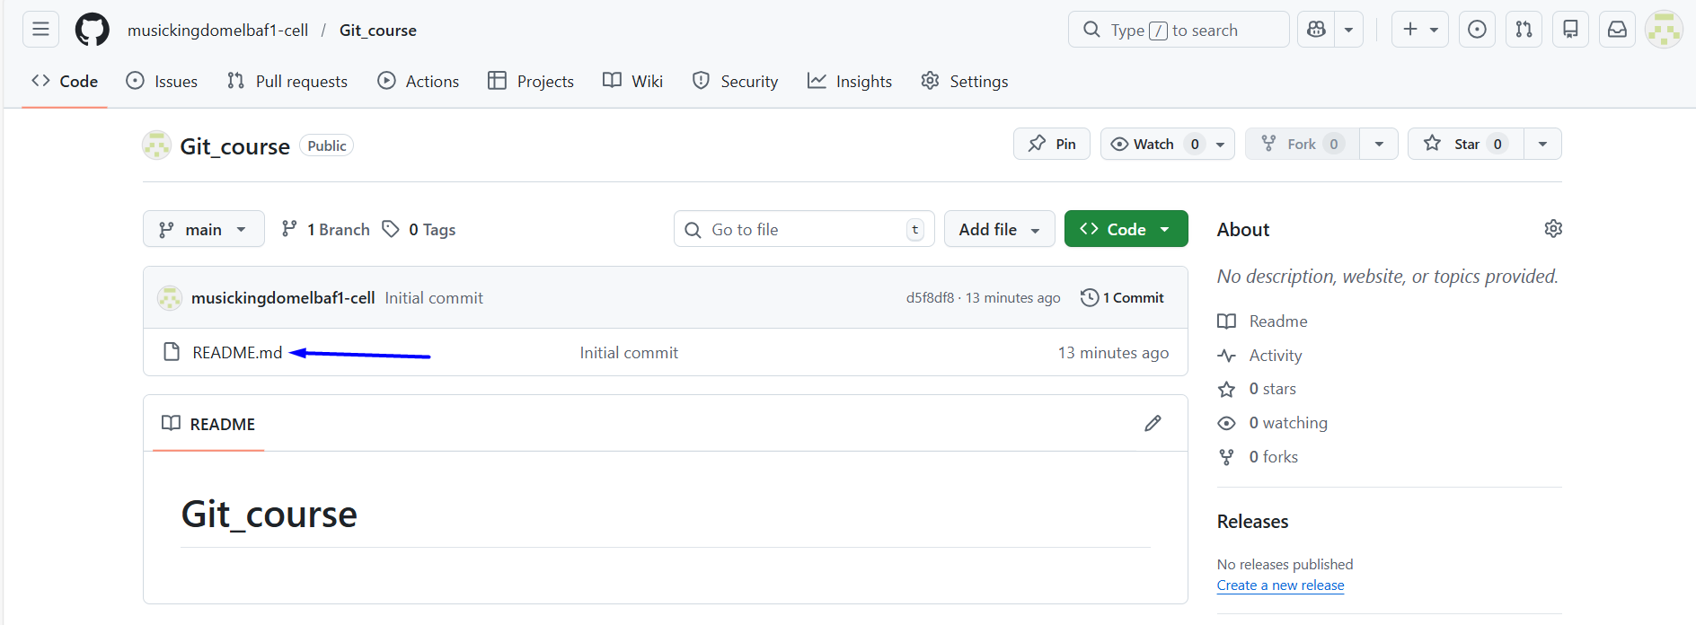
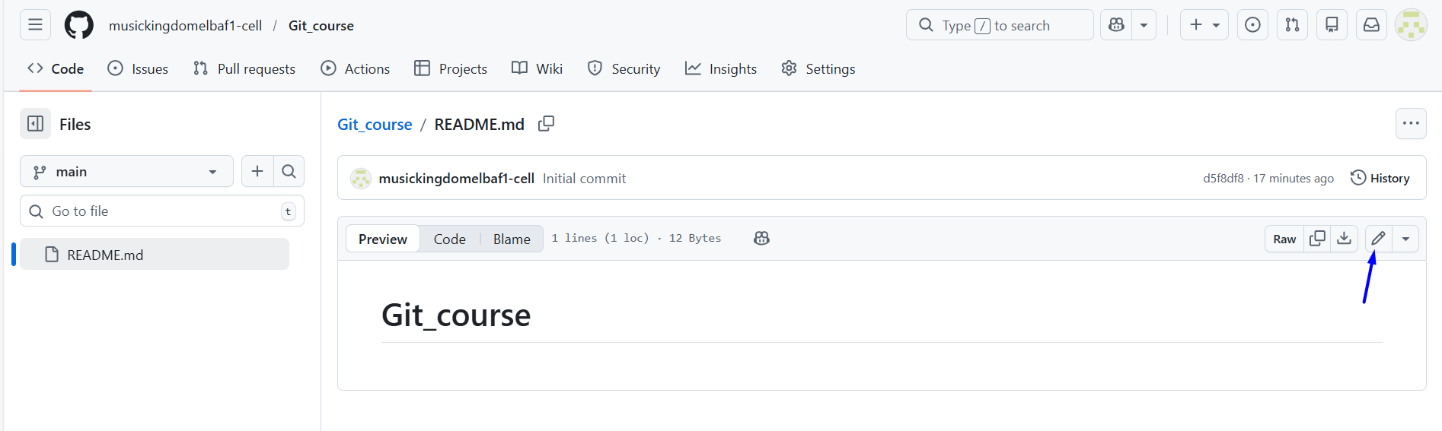
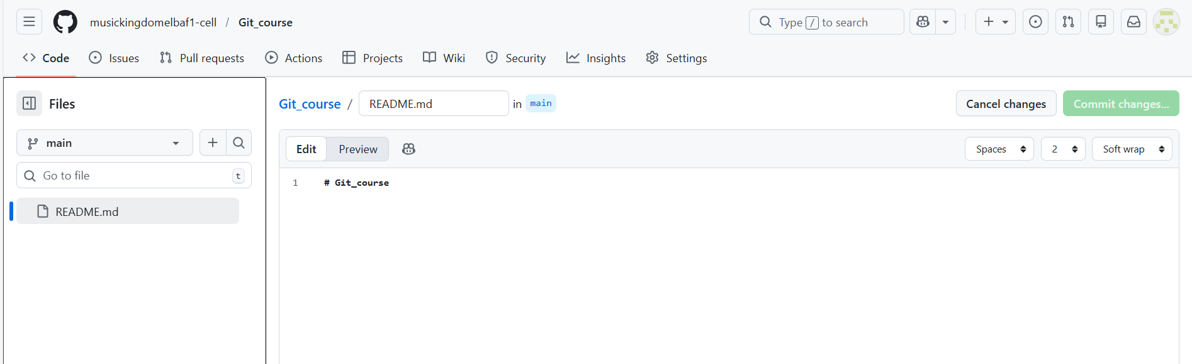
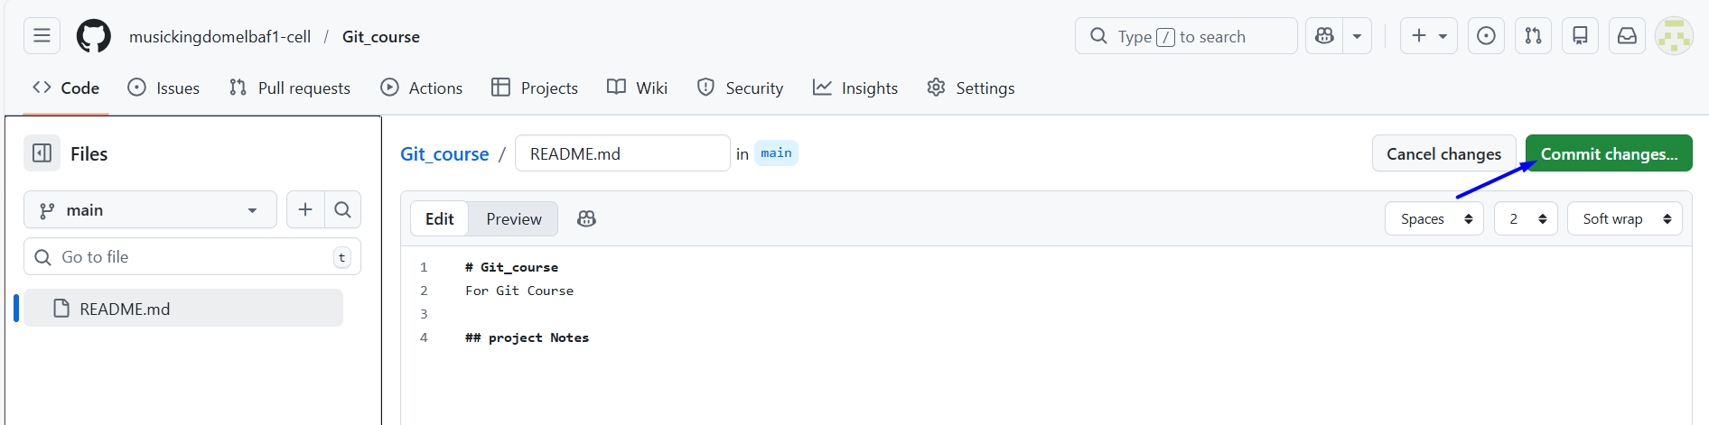
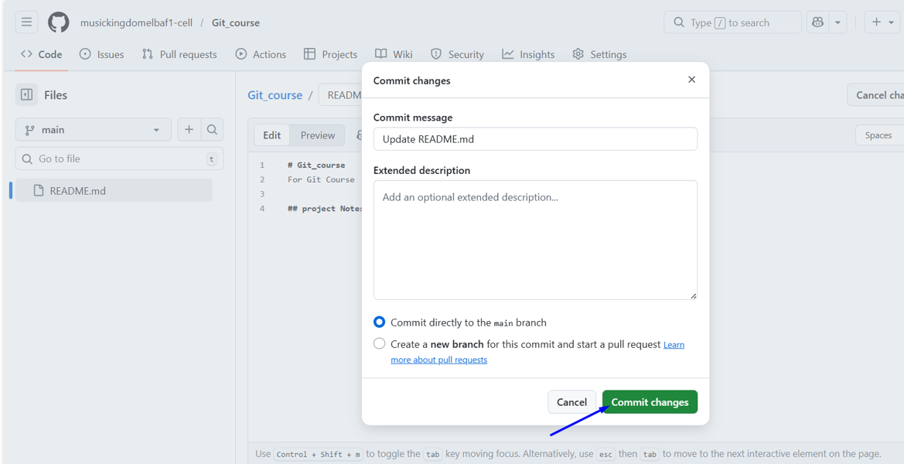

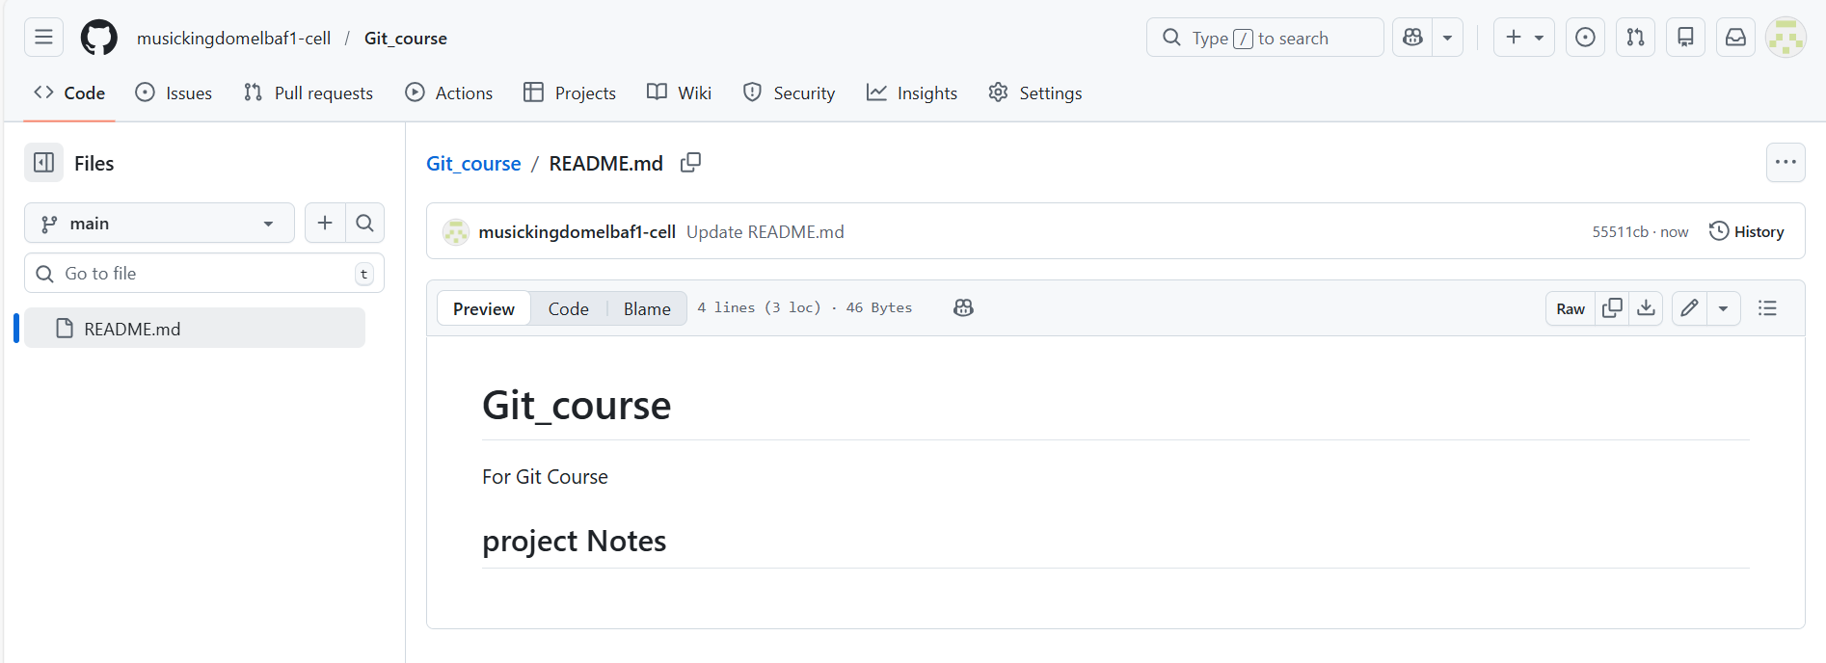

Clone Repository
# Source: ScreenShots Source: Provided by: [Persons Table -> ID Column: 1, Name_En Column: Motasem Essam] -> Tool: [Lightshot Program] -> From [Windows] on [2/16/2026]
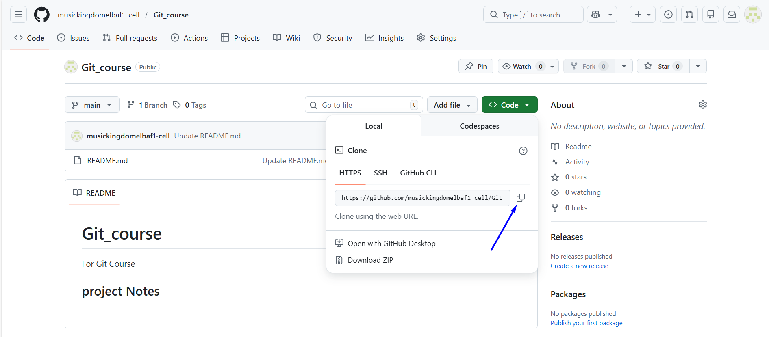
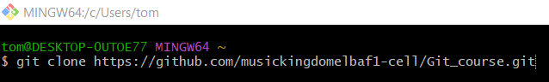
git clone https://github.com/musickingdomelbaf1-cell/Git_course.git
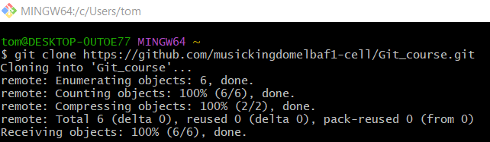
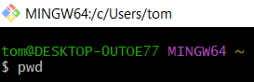
pwd
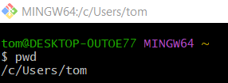
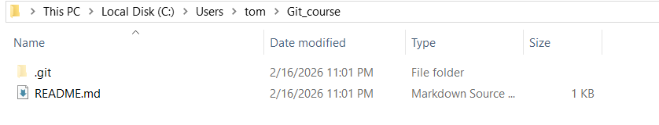

create a new repository on the command line

create a new repository on the command line
# Source: ScreenShots Source: Provided by: [Persons Table -> ID Column: 1, Name_En Column: Motasem Essam] -> Tool: [Lightshot Program] -> From [Site: https://github.com/musickingdomelbaf1-cell/Git_course] on [2/16/2026]
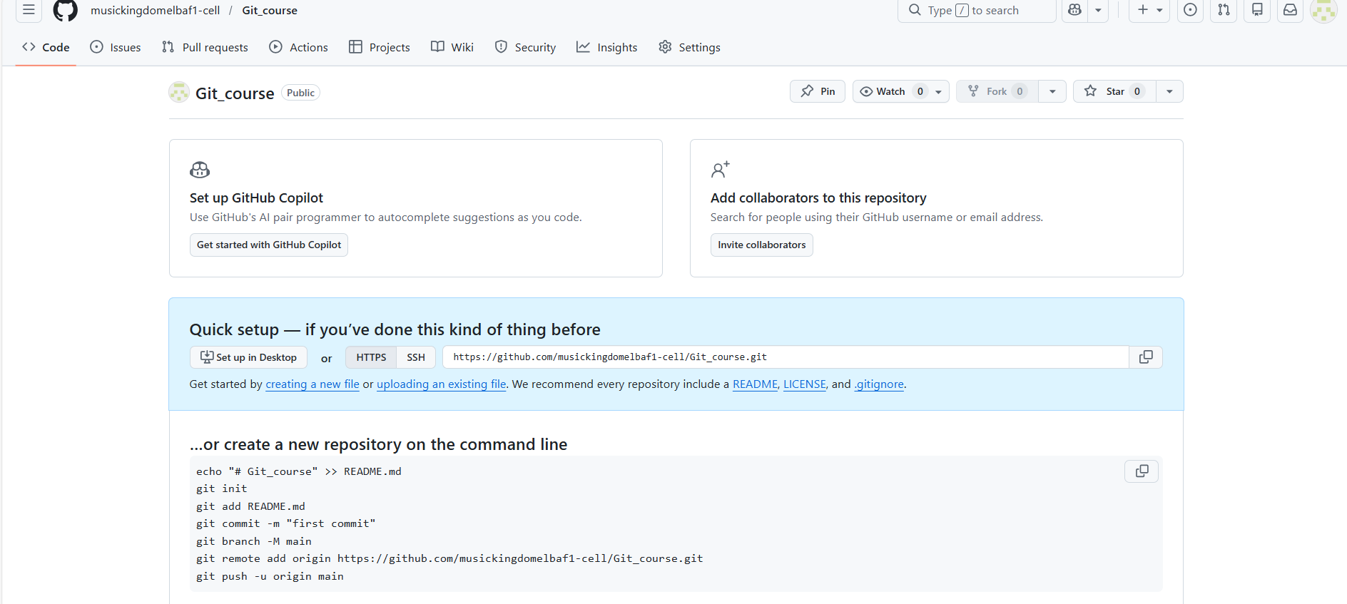
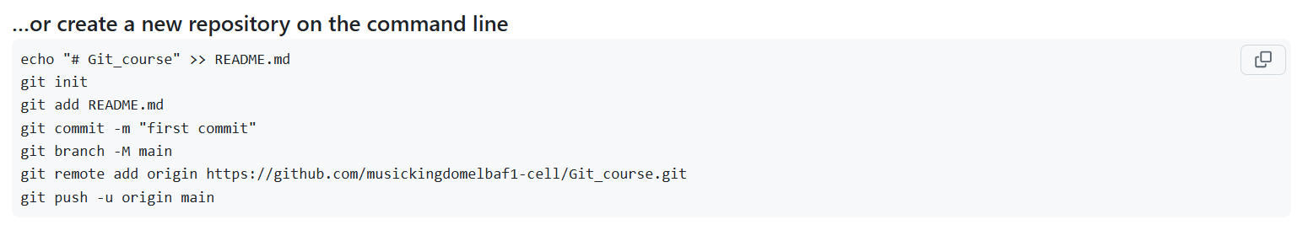

Steps
# Source: AI Source: Provided by: [Data Path: Persons Table -> ID Column: 1, Name_En Column: Motasem Essam] -> From: [Chatgpt (GPT‑5 Mini)] on [2/16/2026]
Here’s how to create a new Git repository from the command line (Git Bash):

1. Go to the folder where you want the repo
# Source: AI Source: Provided by: [Data Path: Persons Table -> ID Column: 1, Name_En Column: Motasem Essam] -> From: [Chatgpt (GPT‑5 Mini)] on [2/16/2026]
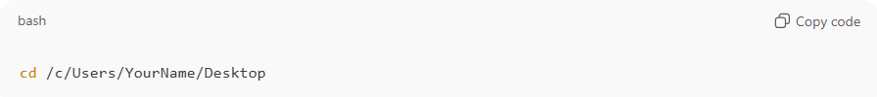
cd /c/Users/YourName/Desktop
(Replace with your path)
Or create a new project folder and enter it:
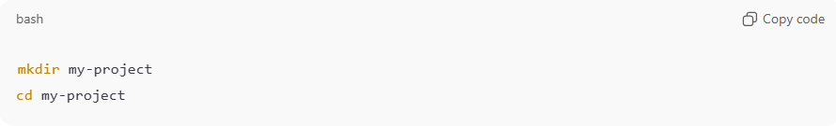
mkdir my-project
cd my-project

2. Initialize a new Git repository
# Source: AI Source: Provided by: [Data Path: Persons Table -> ID Column: 1, Name_En Column: Motasem Essam] -> From: [Chatgpt (GPT‑5 Mini)] on [2/16/2026]
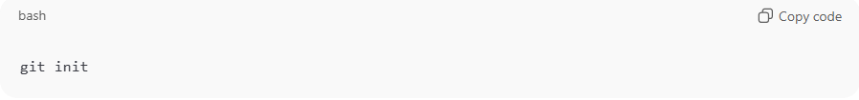
git init
You should see something like:
Initialized empty Git repository in .../my-project/.git/

3. Create a test file
# Source: AI Source: Provided by: [Data Path: Persons Table -> ID Column: 1, Name_En Column: Motasem Essam] -> From: [Chatgpt (GPT‑5 Mini)] on [2/16/2026]
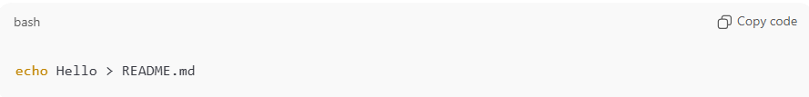
echo Hello > README.md

4. Add the file to Git
# Source: AI Source: Provided by: [Data Path: Persons Table -> ID Column: 1, Name_En Column: Motasem Essam] -> From: [Chatgpt (GPT‑5 Mini)] on [2/16/2026]
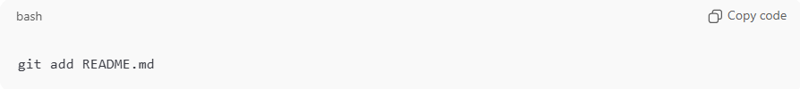
git add README.md

5. Make your first commit
# Source: AI Source: Provided by: [Data Path: Persons Table -> ID Column: 1, Name_En Column: Motasem Essam] -> From: [Chatgpt (GPT‑5 Mini)] on [2/16/2026]
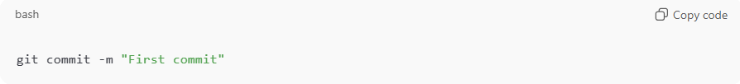
git commit -m "First commit"

6. (Optional) Check repo status
# Source: AI Source: Provided by: [Data Path: Persons Table -> ID Column: 1, Name_En Column: Motasem Essam] -> From: [Chatgpt (GPT‑5 Mini)] on [2/16/2026]
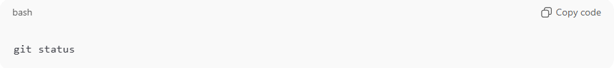
git status

Done 🎉
You just created a Git repository locally.

7. Rename branch to main
# Source: AI Source: Provided by: [Data Path: Persons Table -> ID Column: 1, Name_En Column: Motasem Essam] -> From: [Chatgpt (GPT‑5 Mini)] on [2/16/2026]
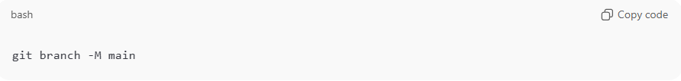
git branch -M main

8. Connect your repo to GitHub
# Source: AI Source: Provided by: [Data Path: Persons Table -> ID Column: 1, Name_En Column: Motasem Essam] -> From: [Chatgpt (GPT‑5 Mini)] on [2/16/2026]
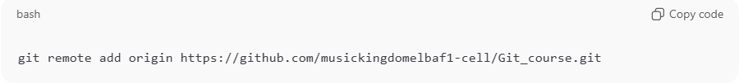git remote add origin https://github.com/musickingdomelbaf1-cell/Git_course.git

9. Push to GitHub
# Source: AI Source: Provided by: [Data Path: Persons Table -> ID Column: 1, Name_En Column: Motasem Essam] -> From: [Chatgpt (GPT‑5 Mini)] on [2/16/2026]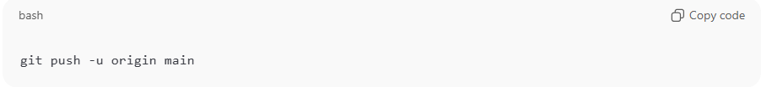
git push -u origin main
Note
If Git asks for username/password
GitHub no longer accepts password. Use Personal Access Token (PAT) instead of password.

Example

1. Go to the folder where you want the repo
# Source: ScreenShots Source: Provided by: [Persons Table -> ID Column: 1, Name_En Column: Motasem Essam] -> Tool: [Lightshot Program] -> From [Windows] on [2/16/2026]
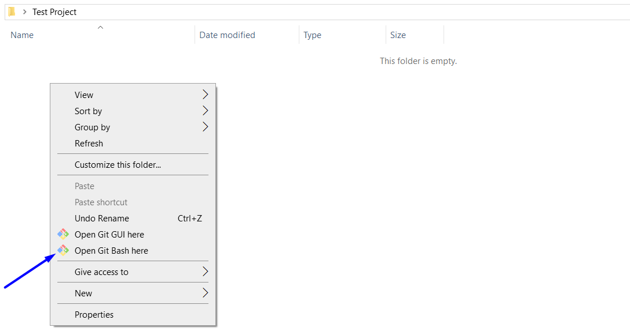

2. Initialize a new Git repository
# Source: ScreenShots Source: Provided by: [Persons Table -> ID Column: 1, Name_En Column: Motasem Essam] -> Tool: [Lightshot Program] -> From [Windows] on [2/16/2026]
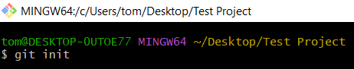
git init
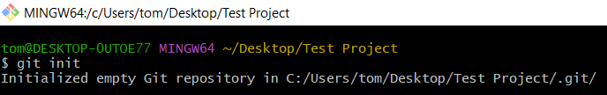
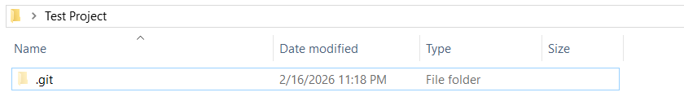
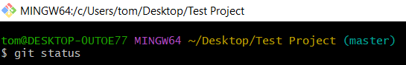
git status
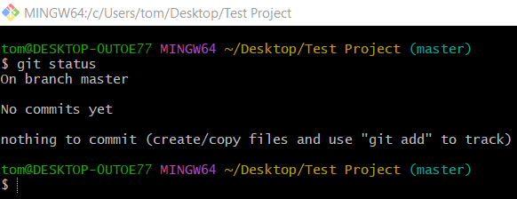

3. Create a test file
# Source: ScreenShots Source: Provided by: [Persons Table -> ID Column: 1, Name_En Column: Motasem Essam] -> Tool: [Lightshot Program] -> From [Windows] on [2/16/2026]
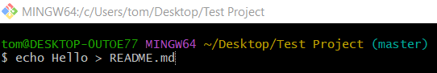
echo Hello > README.md
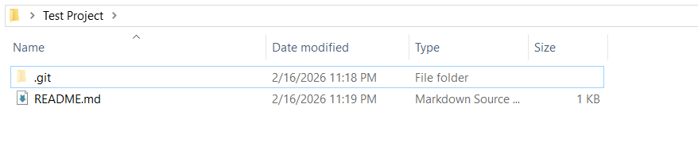
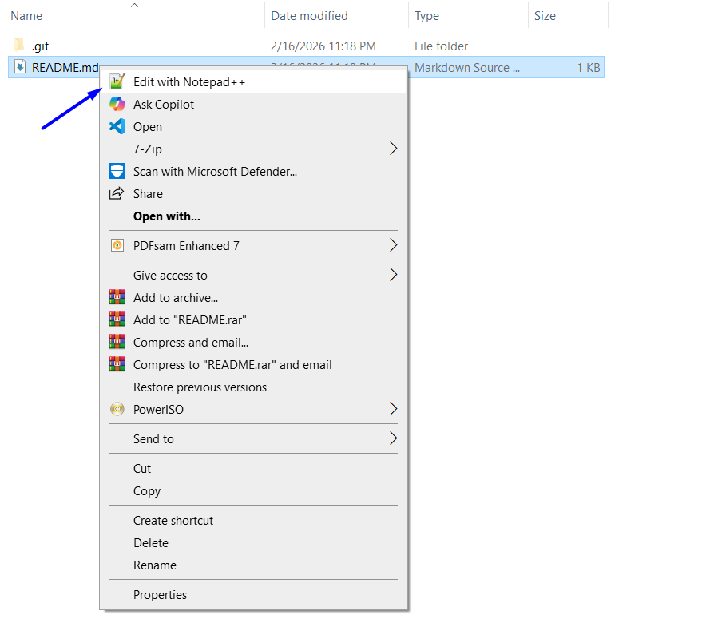
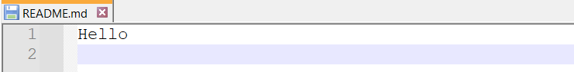

git status
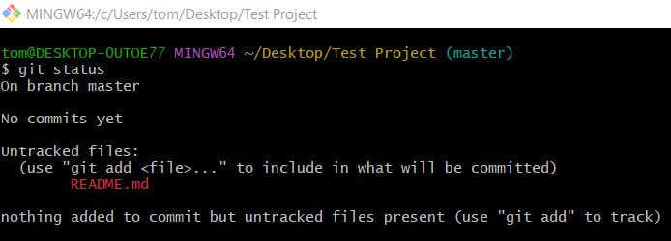

4. Add the file to Git
# Source: ScreenShots Source: Provided by: [Persons Table -> ID Column: 1, Name_En Column: Motasem Essam] -> Tool: [Lightshot Program] -> From [Windows] on [2/16/2026]
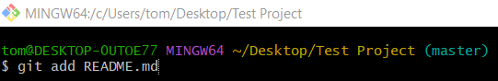
git add README.md

git status
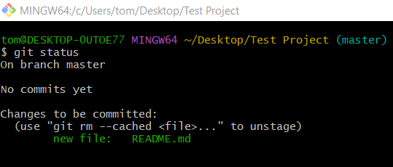

5. Make your first commit
# Source: ScreenShots Source: Provided by: [Persons Table -> ID Column: 1, Name_En Column: Motasem Essam] -> Tool: [Lightshot Program] -> From [Windows] on [2/16/2026]
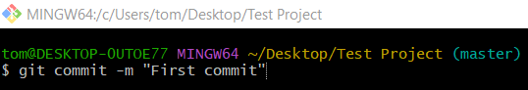
$ git commit -m "First commit"
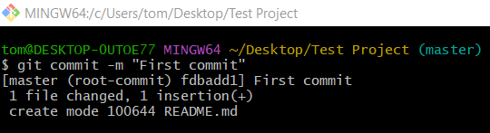

git status
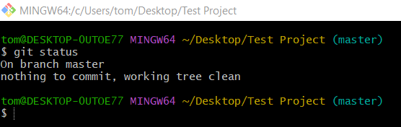

6. Rename branch to main
# Source: ScreenShots Source: Provided by: [Persons Table -> ID Column: 1, Name_En Column: Motasem Essam] -> Tool: [Lightshot Program] -> From [Windows] on [2/16/2026]
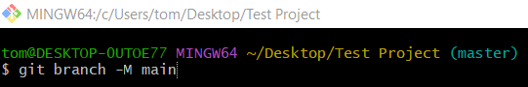
git branch -M main

git status
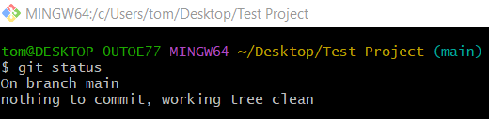

7. Connect your repo to GitHub
# Source: ScreenShots Source: Provided by: [Persons Table -> ID Column: 1, Name_En Column: Motasem Essam] -> Tool: [Lightshot Program] -> From [Windows] on [2/16/2026]
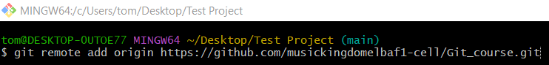
git remote add origin https://github.com/musickingdomelbaf1-cell/Git_course.git


git status


8. Push to GitHub
# Source: ScreenShots Source: Provided by: [Persons Table -> ID Column: 1, Name_En Column: Motasem Essam] -> Tool: [Lightshot Program] -> From [Site: https://github.com/musickingdomelbaf1-cell/Git_course] on [2/16/2026]
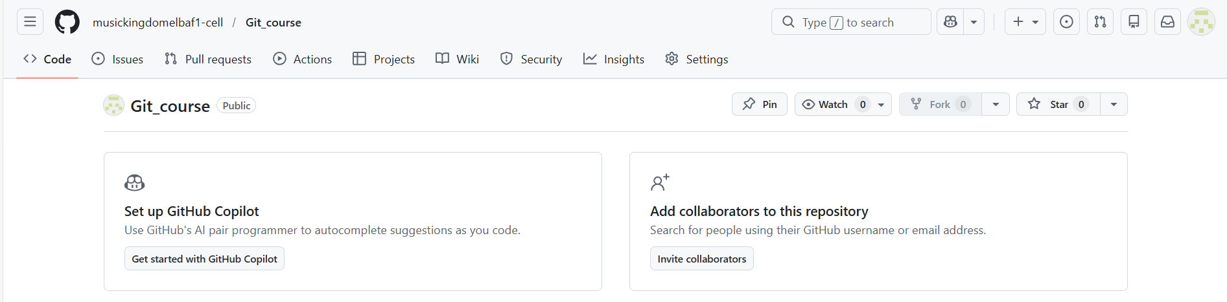
# Source: ScreenShots Source: Provided by: [Persons Table -> ID Column: 1, Name_En Column: Motasem Essam] -> Tool: [Lightshot Program] -> From [Windows] on [2/16/2026]
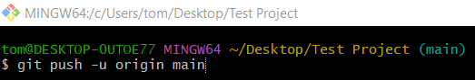
git push -u origin main
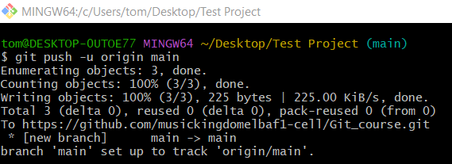
# Source: ScreenShots Source: Provided by: [Persons Table -> ID Column: 1, Name_En Column: Motasem Essam] -> Tool: [Lightshot Program] -> From [Site: https://github.com/musickingdomelbaf1-cell/Git_course] on [2/16/2026]
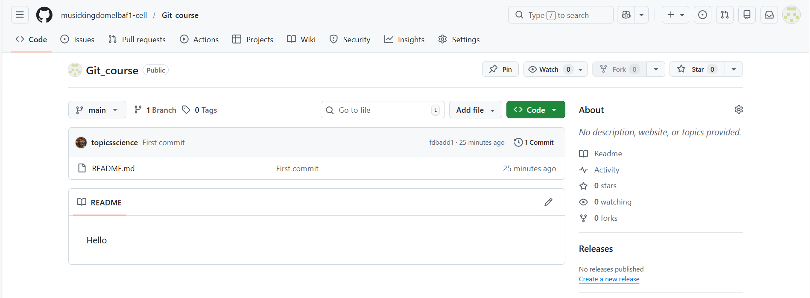

Errors

At Step 7: Error remote origin already exists Error

Error
# Source: ScreenShots Source: Provided by: [Persons Table -> ID Column: 1, Name_En Column: Motasem Essam] -> Tool: [Lightshot Program] -> From [Windows] on [2/16/2026]
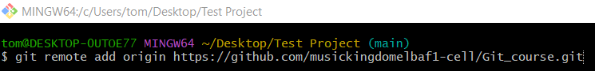 git remote add origin https://github.com/musickingdomelbaf1-cell/Git_course.git
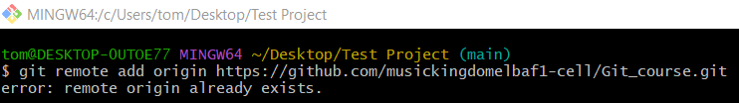

Solve
# Source: ScreenShots Source: Provided by: [Persons Table -> ID Column: 1, Name_En Column: Motasem Essam] -> Tool: [Lightshot Program] -> From [Windows] on [2/16/2026]
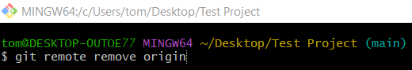
git remote remove origin

At Step 8: Repository not found

Error
# Source: ScreenShots Source: Provided by: [Persons Table -> ID Column: 1, Name_En Column: Motasem Essam] -> Tool: [Lightshot Program] -> From [Windows] on [2/16/2026]

git push -u origin main
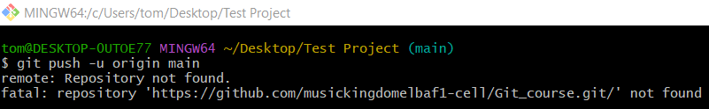

Solve
# Source: ScreenShots Source: Provided by: [Persons Table -> ID Column: 1, Name_En Column: Motasem Essam] -> Tool: [Lightshot Program] -> From [Site: https://github.com/musickingdomelbaf1-cell/Git_course] on [2/16/2026]





At Step 8: Permission Error

Error
# Source: ScreenShots Source: Provided by: [Persons Table -> ID Column: 1, Name_En Column: Motasem Essam] -> Tool: [Lightshot Program] -> From [Windows] on [2/16/2026]

git push -u origin main
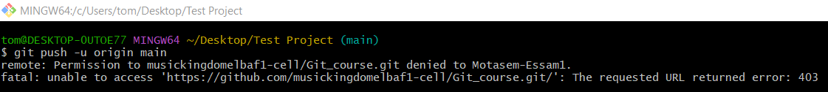

Solve
# Source: ScreenShots Source: Provided by: [Persons Table -> ID Column: 1, Name_En Column: Motasem Essam] -> Tool: [Lightshot Program] -> From [Site: https://github.com/musickingdomelbaf1-cell/Git_course] on [2/16/2026]
